

Preparing

the Way





Glory be to the Father –

in whom we live and move

and have our being.

Glory be to the Son –

whose name we bear

and who calls each of us

to be his disciples;

to build his Kingdom

and to go out into the world

and bear its fruit.

Glory be to the Holy Spirit –

pouring out grace and guidance,

forming us and renewing us.

Inspire us all

in the Diocese of Hexham and Newcastle

to live the Gospel,

to be open to change

and to move forward together in hope

**Foreword**

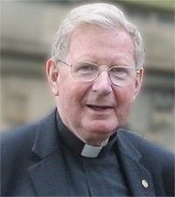The purpose of *Forward Together in Hope*is to help us discover how to be more committed disciples of Jesus Christ. It will also help us find a way of making best use of our resources in order to ensure we have a thriving and sustainable Catholic community into the future. We are blessed with committed Catholic clergy and gifted lay people. At the same time, we have a decreasing number of priests and congregations which are reducing in numbers. It is clear there will be challenging decisions to be made if we are to have a living church in the future. I am convinced that with good will and trust in the Holy Spirit we can embrace this challenge and work together to create a Church which will be life-giving and a beacon of hope in Hexham and Newcastle.

We have already made great efforts in trying to move from a ‘parochial’ understanding of ‘parish’, to a sense that we do actually belong to a flourishing, active and involved worshipping community. However, I appreciate that we are ‘in decline’ in relation to numbers and financial resources, with a heritage of buildings which are becoming impossible to support.

I want to pay tribute to the energy and imagination of those who are involved in *Forward Together in Hope*, and fervently hope that as many people as possible in our Diocese will ensure that this work can be moved forward.

I further appreciate that it is very difficult to move from a Church which has felt secure and not needing to change, to a community that is facing new challenges as a result of a rather rapid decline in numbers and financial resources.

This Diocesan Review is meant to provide us with the ‘context’ in which we’re working: facts and figures about our Diocese; indications of how our communities can flourish in the future; and the process we intend to put in place to engage throughout the Diocese. The aim of the review is to provide information and data which, once explored and analysed, will indicate a framework for the way ahead. It will help ensure that decisions pointing the way forward are made in an informed, transparent and fair way.

Once again I urge you to pray that the Holy Spirit will form and renew us, open us to change and give us the courage to move forward together in hope*.*



+ Séamus Cunningham

Bishop of Hexham and Newcastle

**Forward Together in Hope - Stages of the Journey**

**PREPARING THE WAY**

* Developing liturgies and prayer resources
* Developing and distributing information leaflets and guidance
* Informing everyone about the approach through meetings, documents and a DVD
* Initial meetings and training for clergy and laity
* Bishop Séamus leads prayer and reflection

**Autumn 2014 - Spring 2015**



**EXPLORING THE WAY**

* Prayer and liturgies across the Diocese
* Providing unique data to each parish
* Extensive consultation and self-evaluation process

in each worshipping community

* Support and advice from the Diocese
* Return of completed self-evaluation questionnaire and recommendations
* Detailed analysis and validation of responses
* Clarification meetings and on-going discussions

**Spring 2015 - Summer 2016**



**POINTING THE WAY**

* Prayer and liturgies across the Diocese
* Consideration of recommendations by Diocesan group of clergy and laity
* Information and analysis made available to

Bishop Séamus to take decisions about the future

* Communicating these decisions and indicating the way forward for everyone
* Supporting parishes in moving to the new arrangements

**Autumn 2016 - Summer 2017**

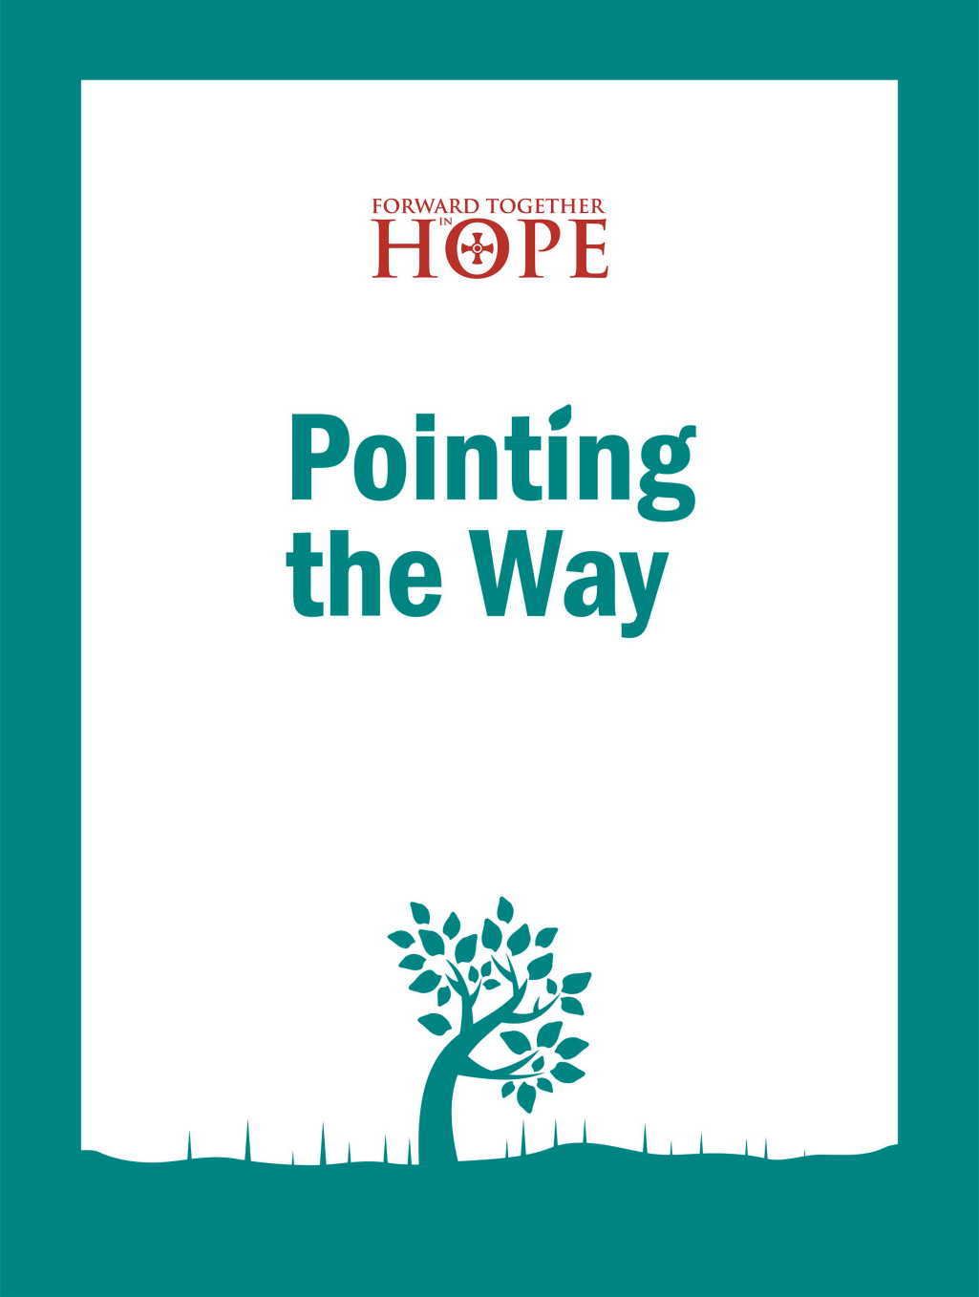

1 Background

*This section explains the approach and timescale for Forward Together in Hope and sets out how the ‘Preparing the Way’ stage fits within the overall journey.*

**1.1 Forward Together in Hope**

*Forward Together in Hope* is our Diocesan journey of renewal. It is about all of us, young or old; lay or ordained; in parishes, schools or housebound working together to explore and discern God’s will for our Diocese. It will not be an easy journey; in the words of Bishop Séamus, *‘This could be painful, but there can be no growth without pain’*.

Between Pentecost and Advent this year, each worshipping community will look in detail at how best it can flourish into the future. Each community will be given information held centrally in the Diocese, and the invitation to every community is to be both painstaking and honest in its approach to a self-evaluation questionnaire.

At the end of the process it is likely that there will be significant change for many of us. Some communities may not be able to worship in their current church but will be able to thrive by joining with a neighbouring community. Other communities, however, may discover a real sense of responsibility in relation to neighbouring communities. A key strength of the approach is that it will take place in the same way across the whole of the Diocese. The entire process will be firmly rooted in prayer and a real openness to the guidance of the Holy Spirit. The success of *Forward Together in Hope* depends on all of us playing our part and thinking beyond the limits of our experience and imagination.



Please get in touch if you have any questions or if you have any comments or suggestions to make.

(0191) 243 3304

hope@diocesehn.org.uk

www.hope.rcdhn.org.uk

**1.2 Stages of the Journey**

We have described the *Forward Together in Hope* process as three stages on a journey - Preparing the Way; Exploring the Way and Pointing the Way - and the overall ‘map’ and timescales for the journey are shown in the diagram opposite. Of course, a journey like this can never really end, but we hope that after 3 years we will have discovered some key indicators regarding the future of the Diocese and have started to put the new arrangements in place. Resources will be provided during each stage of the journey to help worshipping communities to reflect prayerfully on the future challenges and opportunities.

**1.3 Preparing the Way**

The aim of this document and the accompanying resources is to help worshipping communities to make the necessary preparation for this important journey. To assist in this we have provided the following items:

* This document - giving an overview of the *Forward Together in Hope* process and the reasons why we are undertaking it.
* *‘Our Story So Far’*, a brief history of the church in the area, noting that we have never been static; we have constantly adapted.
* A ‘*Diocesan Facts and Figures’* Supplement.
* Prayer and liturgy resources to support your preparations.
* A PowerPoint presentation.
* A CD containing all of the above items and additional materials electronically.
* A short (8 minute) DVD with key messages about *Forward Together in Hope.*

**1.4 Travelling Together on the Way**

We are committed to communicating as well as we possibly can throughout the *Forward Together in Hope* journey. We have put in place a network of lay people to act as communications channels in their worshipping communities. They will also receive all the information and resources being made available to parish priests. We want as many people as possible to feel part of this journey and would encourage you to spread this information as widely as you can.

2 The Theological Context

*This section reminds us of Pope Francis’ invitation to a renewed personal encounter with Jesus Christ and sets out how Forward Together in Hope is a response to this invitation.*

**2.1 Introduction**

When Pope Francis called on the world’s priests to bring the healing power of God’s grace to everyone in need, to stay close to the marginalised and to be ‘*shepherds living with the smell of the sheep’*, he wasn’t suggesting that we should all move to Alwinton in Northumberland, buy a quad bike and a couple of sheep dogs and become hill shepherds. He was inviting all the baptised to become totally immersed in the world in which we live, to be close to the needy and to be changed as a result of this whole way of life. The Pope also invites us to *‘…be revolutionaries. I ask you to swim against the tide; yes I am asking you to rebel against this culture that sees everything as temporary and that ultimately believes you are incapable of responsibility’*.



***‘I invite all Christians, everywhere, at this very moment, to a renewed personal encounter with***

***Jesus Christ’***

Pope Francis is simply expanding on the message at the end of Matthew’s Gospel when Jesus tells the eleven disciples, and by implication all the baptised, to *‘Go, therefore, make disciples of all the nations…’*

We are called to be disciples in a very specific part of the world – a part of the world which has seen enormous changes in recent years. The total eradication of the mining industry and ship yards has left scars in the lives of many families. Yet the signs of regeneration in the cities, development of the universities and research facilities and a wider variety of employment opportunities seem to some people, to be signs of hope in the area.

We live in an area with an increasingly ageing population, significant ethnic diversity and with some extensive, new housing development.

The poor in our area are becoming relatively poorer and there is evidence of more ‘in work poverty’ and increasing numbers of food banks.

*Forward Together in Hope*allows us to explore carefully how our worshipping communities can help form disciples to witness to the Lord in the North East.

**2.2 What are we to do?**

In the last fifty years as a Church, and more locally as a Diocese, we have been trying to better appreciate and implement the teachings of the Second Vatican Council about the Church and its relations with this wider world. Our own Diocesan Vision, published in 2000, was one of the fruits of reflections informed by documents of the Vatican Council.

Among the very many developments which we can trace back to the Council are such things as: a broader understanding of the role of the priest and of other forms of ministry in the Church; a renewed appreciation of the Word of God in the life of the Church; the call to a dialogue with other churches, religions and the world at large; and the call to evangelisation. All of these help us to announce the Gospel to the people of our own time and place. The years since the Council have been challenging ones in lots of ways, and the road ahead looks equally challenging. This is why, as a Diocese, we are now embarking on a new stage of exploration.

In his recent Apostolic Exhortation – *Evangelii Gaudium* (the Joy of the Gospel) – Pope Francis invites us to look at ourselves as disciples of Jesus engaged in evangelisation. He calls on each of us to take up our part in this:

*‘I invite all Christians, everywhere, at this very moment, to a renewed personal encounter with Jesus Christ, or at least an openness to letting him encounter them; I ask all of you to do this unfailingly each day. No one should think that this invitation is not meant for him or her, since*

*‘no one is excluded from the joy brought by the Lord.’ The Lord does not disappoint those who take this risk; whenever we take a step towards Jesus, we come to realise that he is already there, waiting for us with open arms.’ (EG §3)*

This is how Pope Francis begins his call for all of us to share the joy of the Gospel with each other and with others. Fundamental to his thinking is this idea of ‘encounter’. An encounter is more than just a meeting, which implies two or more people coming together, but in that coming together, one or more of the participants may be rather passive. An encounter implies active participation on the part of all concerned. The primary encounter is the one with Jesus Christ in faith. Pope Francis quotes his predecessor, Pope Benedict, who wrote:

*‘Being a Christian is not the result of an ethical choice or a lofty idea, but the encounter with an event, a person, which gives life a new horizon and a decisive direction.’* (*Deus Caritas Est*, §1, quote in *EG*. §7)

Faith makes a decisive difference in our life and we are called to share our experience of what faith means to others.

Pope Francis is well aware both of the joy which the gospel-message brings to our lives, and the challenges of sharing that joy in our world today, but share it we must!

He writes, ‘*The Gospel joy which enlivens the community of disciples is a missionary joy.*’ (§21)



*I hope that all communities will devote the necessary effort to advancing along the path of a pastoral and missionary conversion which cannot leave things as they presently are.*

All of us are aware of the challenges posed by dwindling numbers in our congregations and a diminishing, and ageing, cohort of priests, but the call to evangelise is for everyone in the Church:

*‘I hope that all communities will devote the necessary effort to advancing along the path of a pastoral and missionary conversion which cannot leave things as they presently are. ‘Mere administration’ is not enough. Throughout the world, let us be “permanently in a state of mission.”’*(§25)

*Forward Together in Hope* is our Diocesan attempt at taking up the challenge called for by the Pope.

**2.3 A Church of Missionary Disciples**

This phrase of Pope Francis referring to the Church as a ‘community of missionary disciples’ is building on what Pope John Paul II wrote of the Church simply as a ‘community of disciples’. In expanding the phrase he leaves us in no doubt as to our priorities. He writes:

*‘Evangelisation is the task of the Church. The Church, as the agent of evangelisation, is more than an organic and hierarchical institution; she is first and foremost a people advancing on its pilgrim way towards God. She is certainly a mystery rooted in the Trinity, yet she exists concretely in history as a people of pilgrims and evangelisers, transcending any institutional expression, however necessary’* *(EG* §111)

These words echo the foundational document of the Second Vatican Council on the Church - *Lumen Gentium*(Light of the Nations) - and point us in the direction of how we might express in concrete ways those ideas today. In order to do this we need as a Church and as a Diocese to grow in our understanding of how we go about this task:

*‘The Church is herself a missionary disciple; she needs to grow in her interpretation of the revealed word and in her understanding of truth’* (EG §40)

Here the Pope calls for us to listen to experts in scripture, doctrine, the social sciences, philosophy and pastoral practice as we take up this task of moving on into the future, and he makes very clear other very specific ways in which we might engage with this.

Here are just some of them which might inform our further reflections:

*‘In her ongoing discernment the Church can also come to see that certain customs not directly connected to the heart of the Gospel, even some which have deep historical roots, are no longer properly understood and appreciated. Some of these customs may be beautiful, but they no longer serve as means of communicating the Gospel. We should not be afraid to re-examine them. At the same time, the Church has rules or precepts which may have been quite effective in their time, but no longer have the same usefulness for directing and shaping people’s lives.’* (*EG* §43)

*‘A Church which ‘goes forth’ is a Church whose doors are open. Going out to others in order to reach the fringes of humanity does not mean rushing out aimlessly into the world. Often it is better simply to slow down, to put aside our eagerness in order to see and to listen to others, to stop rushing from one thing to another and to remain with someone who has faltered on the way. At times we have to be like the father of the prodigal son, who always keeps his door open so that when the son returns, he can readily pass through it.’* *(EG* §46)

*‘The parish is not an outdated institution precisely because it possesses great flexibility. It can assume quite different contours depending on the openness and missionary creativity of the pastor and the community.’*  (EG §28)



*A Church which ‘goes forth’ is a Church whose doors are open.*

*Forward Together in Hope* is an attempt to respond to this vision of Pope Francis. When Bishop Séamus and the Diocesan Board met for their annual days of prayer and refection in January 2015, they wondered what ‘success’ for *Forward Together in Hope* would look like. Building on the vision of Pope Francis, this is how they described it.

**2.4 What would ‘success’ look like?**

**We hope for an increased enthusiasm and openness to the presence of the Holy Spirit through prayer** and an awareness of the many different ways of praying, with more churches open allowing more people to take advantage of silence and peace. It may be that more people will find themselves as members of ‘prayer communities’; more people deepening their friendship with Christ and developing a deeper awareness of the presence and power of the Holy Spirit in their lives.

**We envisage a more ‘outward-looking’ Church, a community of ‘missionary disciples’.** This will be marked by increased outreach from worshipping communities, engaging with marginalised groups including: refugees; those seeking asylum; the homeless; the housebound and lonely; families in increasing poverty and many others – and doing so alongside other people of faith and more generally with anyone of good will. Our communities will be more ‘evangelising’ and ‘missionary’ – conscious that the Body of Christ is to engage fully with the world with a view to making the world a better place in which to live.

**For this to happen we need to develop a stronger sense of community.** Fewer priests will mean that every community will need to look to the end of the ‘convenience mass’ and move towards, wherever possible, the celebration of one Sunday mass. This can only help develop a deeper sense of community awareness and provide opportunities for more inclusive and well-prepared celebrations.

**Priests will carry particular responsibility for future developments.** It is hoped that they will feel affirmed in their ministry, become less fearful of change and more trusting in the Holy Spirit to guide us all on our journey. They will come to appreciate their fundamental responsibility to ‘preach and pray’ and call the community together for worship. The Council of Priests will be enthused and see itself as working very closely with other Councils in the Diocese. As priests begin to ‘let go’ of their more peripheral tasks, they will become much more trusting of lay people generally and supportive of lay leaders. Priests will develop the capacity to minster collaboratively.

**We see lay people becoming more prominent in the community.** They will feel more confident in suggesting and exploring initiatives and more comfortable in taking on responsibility. The community will become a place where the voices of lay people will be heard and respected. We will have a much clearer idea of what we mean by ‘lay leadership’ and be able to envisage how lay leaders can be identified and formed. Lay people, priests and religious will be ever-more open to working together for the good of the Church as a whole. New ‘models of leadership’ will emerge which are not dependent on the way leadership has been exercised in the past.

**There will be much more awareness of the contribution of Young People at every level of Church life.** They can be welcomed as musicians, members of all parish groups, including the Parish Council, encouraged to share in parish ministries as well as leading their own initiatives.

**There will be a huge challenge facing us with the increase in the number of buildings available.** We will devise a process to tackle this responsibility, encouraging capacity in local communities to address the issue. We will encourage the maximisation of the asset so that the local community can benefit and the Church is seen to be present in the neighbourhood in a variety of ways. We will seek to dispose of any buildings for which a creative use cannot be found.

**Prayer**

**Discipleship**

**Viability**

**Flourishing**

**Diocese**

**There will be a more generally accepted acknowledgement that there will be clear indications as to what structural changes may be necessary.** We will be parishioners in a Diocese where there is financial stability and belong to a community where decisions have been reached carefully, equitably and as transparently as possible. Our hope is that the whole Diocese appreciates that there will be a need for some ‘restructuring for mission’.

**Finally, we certainly hope that everyone will be engaged in and enthused by our review process;** that we are seen as journeying together and that there is a sense of joy and hope in the Diocese as we move into the future.

**2.5 Conclusion**

Pope Francis is inviting us to become open minded and imaginative in how we become missionary evangelists. It is envisaged that our pilgrimage together ‘*in hope*’ will deepen our understanding of what it means to be the Church in our Diocese and to become closer friends of Jesus.

We hope that each worshipping community will reflect on this vision of Pope Francis and discern what might make this process a success for them.

Key words to reflect upon throughout the months ahead will be:Prayer, Discipleship, Viability, Flourishing and Diocese.In other words, thinking about how we develop a commitment to **prayer,** so that the Holy Spirit will lead us all to become **disciples** of Jesus in **viable** and **flourishing** communities within our **Diocese.**

**3 The Case for Change**

*This section presents some of the challenges that we are facing in terms of numbers of priests and church-goers as well as the current financial picture of the Diocese.*

**3.1 The Current View of the Diocese**

If you have a quick look at the supplement entitled *‘Our Story So Far’*, you will see that things are always subject to change; the Church is always adapting and finding new ways to witness to Jesus in the world. There is a great deal to celebrate in our Diocese; the faith is alive and well. But circumstances are changing rapidly.

(As at 31st December 2014)

We are now facing a time of ‘decline and diminishment’ when it comes to numbers of both priests and people in our communities. The graphs below demonstrate this very clearly.

**a) The Numbers of Priests**

This graph indicates that between 1951 and 2014 the number of active Diocesan priests has fallen from 368 to 106. The number of retired priests has increased from 2 to 53. It is particularly significant that between 1972 and 2014 the number of active priests has reduced from 333 to 106 – a decrease of over 67%.

While it is not really possible to predict accurately how many active priests we will have in the Diocese in 2030, just 15 years from now, a best estimate is that we might have around 50. (See ‘*Diocesan Facts and Figures’* Supplement for details of how we’ve estimated this).

We can take from this estimate that there will be at least 50 more empty presbyteries available to us. The number of priests and people is in decline, but the number of unused properties will increase.

**b) The Age Profile of Priests**

The age profile of our active Diocesan priests has also changed a lot over time. As the graph above indicates, we currently have only 5 priests aged 40 or under; almost half (47.2%) are already aged 65 or over.

**c) Mass Attendance**

Mass attendance has fallen dramatically over the past few decades. Between 1981 and 2013 (the latest published statistics) the figures show a decrease from around 100,000 to less than 37,000, a reduction of over 63%.

Comparing the mass-going population of the Diocese with the overall resident population of the area, we see that the proportion of mass-goers has reduced significantly over time. In 1981 average mass attendance was recorded as 100,019, representing 4.28% of the resident population; by 2013, the recorded mass-attendance of 36,661 represents just 1.57%.

While the number of active priests and the number of people attending mass have both decreased considerably, the number of churches in our Diocese has remained static for many years.

**d) Baptisms**

The number of baptisms in the Diocese has seen an overall reduction (from over 4,425 in 1981 to 3,267 in 2013) although there has been something of an upturn since 2001.

This brief picture of the Diocese clearly indicates that we are already in the midst of major change. The statistics may appear startling, but it is our intention that *Forward Together in Hope* will enable us to respond creatively to this.

**3.2 The Financial Background**

It would be incomplete to present a current view of the Diocese without reference to money. The majority of Diocesan finance is in the hands of the parishes of the Diocese, i.e. about £54m, (approximately 70%) of the total worth of the Diocese, of which £25m is tied up in property.

The Central Diocesan Services and Bishop’s Office account for a further 20%. It is important to note that, apart from secretarial provision, these services were formerly provided by priests. The Central Services (the Curia) are responsible for all the legal compliance work of the Diocese, requiring professionally qualified experts in the field.

The reduction in the number of priests is a great concern as is the decline in the number of mass-goers. This is obviously leading to a decrease in general giving to the Church. Official figures reveal that the offertory collections in the Diocese have decreased, in real terms, by 20% in the last 5 years.

You will find much more information about the current state of the Diocese, including further statistics and more detailed financial data in the supplement entitled *‘Diocesan Facts and Figures’*.

**3.3 How are we to respond?**

One way of responding is to explore how viable our communities are. This can include what indicators there are which point to future flourishing. Some communities may well discover that they would be wise to move alongside another community so that both can move forward together. This would enable us to make better use of the limited resources available to the Diocese. At the same time, we can reach out to the many who no longer pray with their community on a regular basis.

In recent years the clustering of parishes has been a helpful step. However, it is becoming clear that in the future some of these ‘clusterings’ will no longer be sustainable. The maintenance of 177 Diocesan churches is clearly impossible. Unless there is some change that we cannot foresee, resulting in a sudden increase in the number of men ordained as priests, the time is rapidly approaching when it will not be possible for mass to be celebrated every Sunday in every church in our Diocese. We may well be able to manage with 50 priests in 2030, but it will mean that our expectation of priestly ministry will be focussed not on past or present presumptions, but on future realities.

The current situation in our Diocese is mirrored in most other dioceses in the country. Many dioceses are exploring how best they can make the most of the resources they have. Simply staying as we are is not an option. But these facts can present us with opportunities. As we seek creative ways of rationalising and making better use of the energy and gifts we do have, new ways of seeking to become disciples of Jesus are sure to emerge. We believe that we are now at the stage where we need to review the viability of our worshipping communities.

The reasons for the increasing decline and diminishment in the number of churchgoers are complex, and beyond the scope of this reflection. There has been a gradual dissolution of the distinctive Catholic subculture. It has not been sudden and has taken place over a number of decades. We have attempted ‘business as usual’, but the fall in the number of priests is one of the triggers that makes us realise that the system in which we grew up is no longer sustainable.

The underlying questions around ‘How do we ensure that our Church is viable and flourishes in our area and how can we organise it?’ are being faced in different ways around the world. The retired bishop of Aliwal in South Africa, for example, would say:

*‘Passive communities look to the priest or priest-substitute to provide services to them. Active communities are those where, through a tradition of community building, teams of well-trained leaders involve the whole community in taking responsibility for all the essential tasks of the Church’s life and lack only the ability to celebrate the Eucharist.’*

Real change implies the appreciation by both priests and laity that issues around power and shared responsibility, service and ministry will come to the fore. Exploring these issues will be a very important task.

As we look to the future and wonder how we are to become dedicated disciples of Jesus we may well need to look fundamentally at a whole range of questions and issues in the light of the Gospels, and some of these questions might be:

* Which stories in the Gospels could encourage your community to become more committed disciples of Jesus?
* Which stories in the Gospels could encourage your worshipping community to become more involved in your neighbourhood?
* What will help us to realise that there might only be one mass per community?
* How do we actually feel about moving towards the end of the celebration of mass that is simply ‘convenient’?
* How do we begin to take the risk to explore new options rather than lament the loss of what used to be?
* What do we imagine ‘Lay Leadership’ to look like?
* In the light of all the above, which stories about Jesus in the Gospels provide you with hope today?

The only thing Jesus tells us about the future of the Church is that it has one.

*‘Behold I am with you until the end of time’*

*(Mtt 28:20).*

This Church of ours exists for the whole of humanity, not for its own survival. It does not exist to perpetuate its own existence. We really do not know anything for certain about the immediate future of the Church. If we did, we might be astonished. In the 6th century believers could never have imagined that by the 8th century, vast areas that had been the central homelands of the Church would be populated by followers of a religion that did not then exist. In the 16th century it would have been unimaginable that by today most members of the Church would be non-Europeans[1]. Questions about the future of the Church are often asked by people who do not particularly like the direction in which it seems be going. However it is becoming evident that the Church cannot simply return to the past but needs to welcome the future.

We need to be careful that we do not become over-concerned with structures, organisation and fear of change. We do need to keep the focus on ‘discipleship’, ensuring a viable and flourishing Church with an ‘evangelising/missionary’ direction. Fr Hubert McCabe OP used to say that it was dangerous for the Church to become ‘interested in Christianity instead of being interested in the world’. Pope John Paul II asked us to become ‘passionate about the Gospel…and experts in humanity’.

The theory is one thing, but the fact is, we are facing a tough future. We need to recognise the meaning and significance of loyalty which parishioners feel towards their local church building and, therefore, the fear and defensiveness that appears when there is a hint that ‘their’ church might ‘close’ or their parish be amalgamated with another. It is not simply a matter of habit or prejudice or a simple unwillingness to change, though all these factors play a part. It may well be a more fundamental question about where the ‘holy’ is to be found.[2]

 ‘In a secularised world where the public signs of God are minimal or highly ambiguous, the familiar space of the church building with its direct and overt connection with the divine is a haven of meaning which sustains and strengthens the faith and prayer of those who worship there’.[3]

*The ‘presence’ of the Church is not defined by a building, but by the witness of the community.*

Those who worship rarely, and those who have never worshipped, can be even more upset, since the familiar landmark no longer carries the meaning and significance it did. These concerns can have a deep and lasting impact on people and need to be treated with great respect.

We need to be very careful about the language we use. Words such as ‘closure’ and ‘merger’ may add to the problem. ‘Closure’ reinforces the idea that it is the building that is the Church. It clearly is not. ‘Merger’ sounds like it is a profit-maximizing commercial company - which it certainly is not! The ‘presence’ of the Church is not defined by a building, but by the witness of the community. We are being invited to rediscover what the earliest followers of Jesus fully appreciated, namely that the Church, the Body of Christ, is the people, not the buildings within which they meet.

In conclusion, there is no easy way to respond to our current situation. As we pray together and focus on the themes of ‘discipleship’, ‘viability’, ‘vitality’ and ‘flourishing’, ways forward are sure to emerge. When we see people in the community beginning to explore the future, they may well be inspired to imagine something different.

In the letter to the Ephesians (Eph. 2:22), we are reminded that Christians are ‘built together to become a dwelling in which God lives by his spirit.’ When we make this our own and see Jesus as the cornerstone, the apostles and prophets as the foundations, the result is the creation of a Holy Temple, made of ‘living stones’.

In the light of this statement of faith, we can all respond and contribute to a future flourishing Church in our Diocese.

4 Preparing for the Journey

*This section presents an overview of the self-evaluation process and offers ideas for preparing to complete the questionnaire later in the year.*

**4.1 What will the process involve?**

In May 2015, every worshipping community will receive a detailed self-evaluation questionnaire to be completed between then and the end of November. They will also receive a pack of data with details about their community extracted from information held centrally by the Diocese.

The process will allow every community to look carefully at how well it nurtures discipleship. It will show how each community has traditions and practices which celebrate the fact that we are baptised Catholics and proud of our responsibility to witness to the Lord in our world.

We are providing some advance information about the areas that the questionnaire will contain, so that communities can pray about it and begin to explore their viability and how they can continue to flourish in the future. There will be ten headings relating to key areas of Christian life in the self-evaluation questionnaire. Here, under each heading, we offer a few suggestions and ideas to encourage initial thinking and discussion.

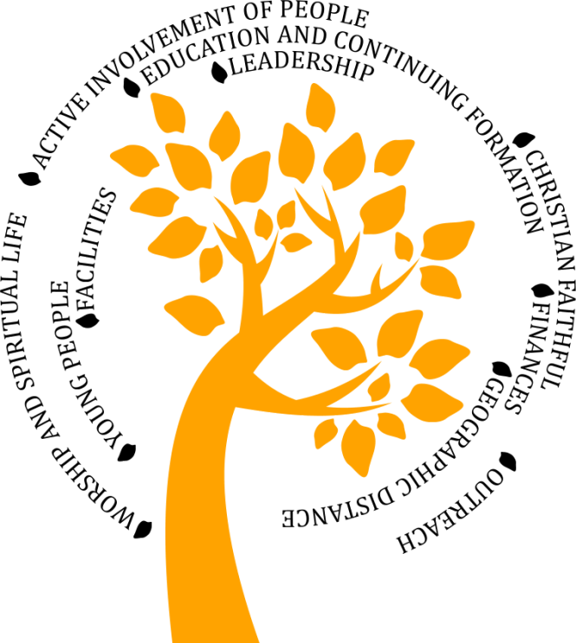

**The 10 headings that will feature in the questionnaire**

A significant weakness in some of these key areas may not mean that the community is not viable. It would, however, point to areas that need further attention. Major weaknesses in a significant number of these areas, would be a strong indication that a community may well struggle in the future. The question is then about how best to support everyone to grow in faith and knowledge of the Lord.

**4.2 The ten key areas**

* ***The Christian Faithful***

The Christian Faithful are the heart of every worshipping community. If it is to flourish, a community needs a core of members who are truly committed to the Gospel of Christ and are willing to make the parish a priority, giving generously of their time, imagination, gifts and other resources. A viable parish needs a minimum number of active members.

* The community could look at how the congregation has increased or decreased over the last 10 years or so.
* No worshipping community is in isolation from its local environment. It might help to discover if there are to be any significant housing developments in the coming years, or any planned ‘relocation’ of people.
* The age profile of a worshipping community can be revealing, as can the impact of Catholics from other countries over the last 20 years or so.
* ***Leadership***

It is certain that in the future, even more parish communities will be sharing a priest with other worshipping communities. The ability of priests to work collaboratively with lay people is essential.

It is not reasonable to ask priests to provide pastoral ministry to an unrealistic number of parish communities. There is a danger that some people will expect the priest to simply celebrate the sacraments without being involved in the life of the community. A flourishing Eucharistic Community will need the ministry of at least a part-time priest who can oversee and become immersed in the community. It will become increasingly important that leadership in the community is not solely dependent on the priest and that there are other leaders with whom the priest can work collaboratively, for example, an appropriately trained deacon, religious, or lay person.

* Every parish must have a Finance Committee, but very many communities benefit from having Parish Councils or Pastoral Councils or other groupings which help to stimulate the life of the community.



*It always seems impossible until it’s done.*

**Nelson Mandela**

* How will fewer priests impact on the ability of your community to flourish?
* What qualities would you imagine are important for those lay people who may emerge as leaders in the future?
* In what areas would you see their leadership being exercised?
* ***Active Involvement of People***

A flourishing community needs the involvement of a significant number of actively involved people. In parishes where the same small, ageing group of parishioners bears the burden of parish leadership and gives a great deal of time and energy, there must be some serious concern about the future. As that small group retires and withdraws from active involvement, the parish is at risk of floundering if younger parishioners are unwilling or unable to take their place.

* How do you imagine younger people can be invited to accept responsibility for various ministries in the community?
* How are different groups served in the community; e.g. those who are unemployed; those who are bereaved; those families that struggle with very low income; those who are vulnerable and fragile; those who are housebound?
* ***Worship and Spiritual Life***

A flourishing community has worship at the centre of its life. The ultimate goal of every parish is to make Jesus Christ known and loved. This is why Jesus Christ is at the heart of every worshipping community. The Eucharist is the principal means in which we celebrate this. For this reason a living parish community makes every effort to encourage parishioners of all ages and backgrounds to participate in the Eucharistic life of the parish.

The celebration of the sacraments calls the parishioners to conversion. Prayer, scripture-based preaching and a variety of devotions and opportunities for continuing adult formation will all enhance the life of the community. It is becoming more important that each parish works with neighbouring parishes in developing a realistic mass schedule.

* How can more members of the Community become involved in preparing a variety of services and devotions?

If we want to follow Jesus then we will give priority to meeting with him at Sunday mass. If it is the case that the Diocese will only have around 50 active priests in 2030, then fewer priests means fewer masses. It could also mean, however, that both clergy and people will be able to plan and celebrate the liturgy with more care, joy and enthusiasm. There can be no place for the old ‘convenience’ mass. There is a big difference between a parish and a mass centre. We need to ensure that the worshipping community becomes a true community and is not simply an experience of ‘being at mass’.

* ***Education and Continuing Formation***

A flourishing community will be able to show that the Catholic faith is handed on to children, young people and adults by means of regular programmes of religious education and Christian formation.

There are many opportunities throughout the year for priests and people to engage in continuing formation. There are frequent days of reflection for those involved in ministries in the community.

There is a great deal to celebrate within our Catholic school network. Every school has the opportunity to become a ‘worshipping community’.

* How can the experience of the local schools be brought into the whole process of *Forward Together in Hope?*
* How can the parents of children in our schools be included in this review?
* How might School Governors, particularly if they are from the worshipping community, help the school and the parish to work together for the good of all?
* How might the local school community assist with the formation of the parents of young people who attend the school?
* ***Outreach***

A flourishing community extends a spirit of hospitality and invites people to become members.

* How can the community demonstrate a clear awareness of, and support for, the larger Church locally, nationally and internationally?
* How does the local community, on its own or in conjunction with neighbouring communities, exhibit practical outreach and service to the poor, the needy, and the homeless?
* How does the community worship and work alongside other Christian communities in this witness to the world?
* What links can be made with members of other Faiths?

Pope Francis invites us to become ‘missionary evangelists’ – to look outwards, beyond our local communities, to the world we are in.

* ***Finances***

A sustainable community must have an annual income that is sufficient to cover its expenses. There needs to be a reliable level of stewardship among the faithful who willingly give of their time, gifts and energy to sustain the work of the community.

* What consideration is being given to sharing resources with neighbouring communities and parishes?
* How aware is the community of its own financial situation?
* How could a ‘finance-rich’ community assist one which doesn’t have financial resources?
* ***Facilities***

A flourishing community needs good facilities which it must be able to maintain properly. It cannot undertake any building projects, renovations or improvements, unless it has the resources to pay for them. Decisions about updating property cannot only depend upon financial resources; they must also include pastoral considerations. It may be that we need to come to an understanding that a deep personal attachment to the church buildings may not be an adequate reason for maintaining a parish or judging it to be viable.

* What ideas are there in the community for the more ‘open’ use of unused or under-used property?
* How can the community as a whole benefit from our facilities in some way?
* Are there people with energy and capacity in the community who can explore a range of options for the property?
* ***Geographic Distance***

A flourishing parish may be influenced by its location. The proximity of neighbouring parishes can have a real impact on the vibrancy of a parish. If several parishes are in close proximity with large, ageing buildings that are only half-full, this will need to be taken into account when considering the future.

The struggle to maintain underused buildings can undermine the true purpose of the evangelising community. Local communities may need to give consideration to using one parish facility that is in good repair and large enough to accommodate nearby smaller parish families. Parishes are not private chapels maintained simply because the parish has enough money to cover the expenses.

* ***Young People***

Young people are not just the ‘future’ of the Church; they are very much part of the present.

The worshipping community may want to look at how actively young people are encouraged and affirmed in their contribution to the community throughout the year. The enthusiasm of young people can be daunting at times, but it can also be a sign of the Spirit among us. The contribution of the Youth Ministry Team (YMT) and the Emmaus Youth Village is well known to many. These particular facilities and opportunities can make a significant contribution to the way young people develop their sense of belonging to the Church.

* How does the community celebrate the presence of young people within it?
* What projects are currently focussing the interest and enthusiasm of young people in the community?
* What relationship do the young people have with YMT?
* What ways are there of being ‘in touch’ with young people who have very little contact with worship or school?

**4.3 Clusters and Amalgamated Parishes**

Once individual communities have taken the opportunity to work through the self-evaluation questionnaire, those parishes which are part of a cluster arrangement may well find it important to look at their findings with other communities in the cluster. There are obviously significant benefits to an individual community being part of a larger grouping of parishes. These can include: shared resources; shared personnel; sacramental preparation; faith formation programmes; adjusting of mass schedules in a realistic way and an increase in cooperation among schools.

Some parishes have been amalgamated in recent years. The *Forward Together in Hope* process could offer an opportunity for them to review how integration has gone and give some indications towards future improvements.

**4.4 How can we prepare?**

The self-evaluation process is not just about numbers; it is also about the things we do well and our plans and aspirations for the future. Nor is it a wish list of what might be; it is an invitation to be realistic. Although it is clear that the number of priests and worshipping parishioners in our diocese is decreasing, the presence of the Church is guaranteed, even if this presence takes on a new look.

In preparation for the *Forward Together in Hope*journey you may wish to consider the following questions and suggestions:

* What structures will you put in place to carry out the self-evaluation process and the completion of the questionnaire? Are these existing arrangements or will new ones be required?
* How will you use these ‘Preparing the Way’ resources (including the DVD and PowerPoint presentation) to help prepare parishioners for the process?
* In what ways will you utilise the liturgy and spirituality resources to put in place a prayerful foundation to *Forward Together in Hope*?
* How can you ensure that the hopes and ideas of those who are housebound are fully incorporated?
* How might you ensure that the views, hopes and aspirations of young people are included in the whole process?
* Ideally, every parishioner, both regular worshippers and those who have a more ‘casual’ relationship with the community, can be involved in this whole exercise. How can the more regular groups – Parish Council, Finance Committee, SVP, coffee groups etc. explore ways of engaging with less regular worshippers?
* The *Forward Together in Hope*prayer could be said at daily mass, or weekend masses, or at the beginning of the regular meetings.
* Perhaps parishioners working together could start to look at the 10 questionnaire headings and begin to assemble information around the various topics. The process does not need to be rushed, but it might help the whole community to address the issues more carefully once the questionnaire arrives.

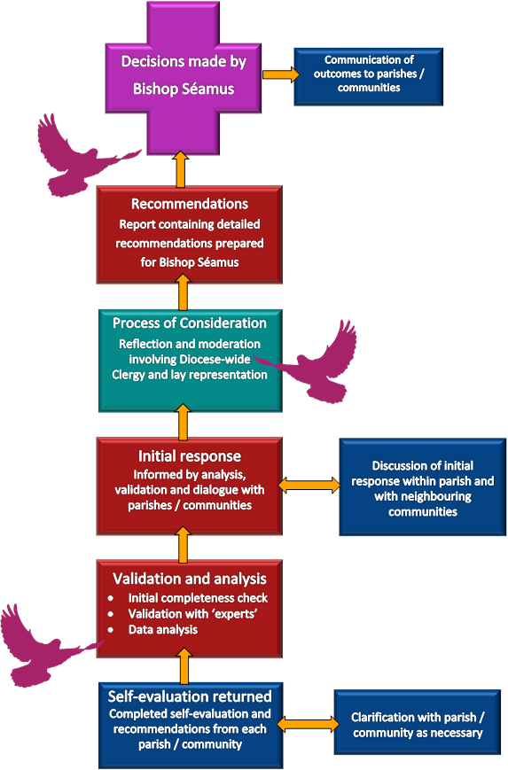**4.5 What happens next?**

When Bishop Séamus launched *Forward Together in Hope*, he said that he wanted it to be ‘transparent and accountable’. The diagram provides the outline of how we intend to be both.

In May this year, the self-evaluation questionnaire will be provided for each worshipping community, along with the detailed information we hold in the Diocesan Offices. We request that these questionnaires be returned by Advent. Any anomalies will be checked with the community.

All the data will be collated and analysed and the results will be returned to the community so that each one has the opportunity to see itself in a slightly different way. At this point it is hoped that communities will explore their circumstances with neighbouring communities to deepen the relationships and begin to learn from one another. This offers opportunities to explore the broader context for the worshipping communities and to see how we can work together more effectively in the future.

Once this has been done, the results will be collected once again and will be looked at carefully by a wide-ranging group of priests and people so that their views and perspectives can help finalise the indications, pointers and recommendations for the Bishop.

Bishop Séamus will then consider carefully what has been suggested and be in a position to begin to make some more long-term decisions.

We hope that these notes give some indication of the discussions that will need to take place in the weeks and months ahead. If you have any comments or questions, please don’t hesitate to contact the *Forward Together in Hope* Team.

Tel: (0191) 243 3304

E-mail: hope@diocesehn.org.uk

Web: www.hope.rcdhn

**The process in outline**

**Acknowledgements:**

We see *Forward Together in Hope* as a shared responsibility of everyone in our Diocese and are very grateful to the many individuals and organisations who have contributed in various ways to the development and distribution of the materials in this resource pack.

In particular, we would like to thank:

* The dioceses that have carried out similar reviews and from whom we have ‘borrowed’ some good ideas. The work of the Diocese of Bellvue in Illinois has been especially helpful.
* Xavier Javier for his creative designs.
* Bill Campbell and Xavier Javier who produced and filmed the DVD.
* Those who feature in the DVD, including Julia Firbank, Chair of the Council of Laity, and two of our school pupils, Angel and Nathan.
* Fr David Milburn and Leo Gooch who provided much of the historical material for the *‘Our Story So Far’* supplement.
* The authors of the photographs we have used for allowing us to use their images.
* Dr Sean Hall and other colleagues for their assistance in developing the *Theological Context* section.
* Kathryn Turner and Karen Brown who developed the prayer and liturgy resources.
* Members of the Diocesan Development Group who oversee the work of *Forward Together in Hope*, namely, Fr Martin Stempczyk, Bill Dryden, Kathleen Smith and Kathryn Turner.
* The clergy and lay representatives who have been so co-operative in making this material available to those in worshipping communities.

Finally, very many thanks to my two colleagues Nancy Gash and Tony Sacco, and many others in various Curial Departments. While we have done our best to ensure that all information included in this resource pack is accurate and that any appropriate copyrights have been acknowledged, I apologise in advance and take responsibility for any omissions or inaccuracies you might discover.

**Jim O’Keefe**

Diocesan Development Director

The *Forward Together in Hope* team: Jim O’Keefe, Tony Sacco and Nancy Gash can be contacted on:

Telephone: (0191) 243 3304 E-mail: hope@diocesehn.org.uk

C:\Users\nancy.gash\AppData\Local\Microsoft\Windows\Temporary Internet Files\Content.Word\Hope Logo [Converted].eps

Diocese of Hexham and Newcastle, Department for Development and Renewal

Tel: (0191) 243 3304 E-mail: hope@diocesehn.org.uk Web: www.hope.rcdhn.org.uk

©Diocese of Hexham and Newcastle – March 2015

Also available in other formats

1. Timothy Radcliffe OP ‘The Future of the Church’ Priests and People August 2004
2. David Morland OSB ‘Catholic Communities and Parish Structures’
3. Ditto